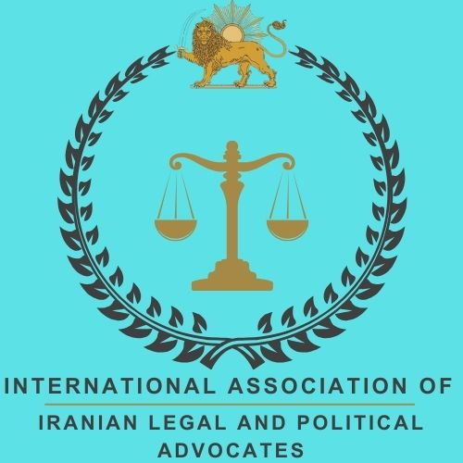
International Association of Iranian Legal and Political Advocates (IAILPA)
167-169 Great Portland, 5th Floor, W1W 5PF, London, UK
info@iailpa.org
www.iailpa.org 10-10-2026

Legal-Political Statement of the International Association of Iranian Legal and Political Advocates, IAILPA On the World Day Against the Death Penalty
Justice is not served by eliminating the “right to life” and irreversibly excluding an individual from society!
What is being carried out in prisons under the title of administering justice not only lacks legal legitimacy from the perspective of international law but is also part of the systematic and organised machinery of the physical elimination of protesters under the cover of domestic laws.
This flagrant violation of the fundamental principles of human rights constitutes compelling grounds for demanding an immediate halt to executions and an international examination of the situation of Iran’s judicial system and prisons.
Let us bear in mind that the criminal justice system in Iran is an inquisitorial, confession/admission-based system. In such systems, a confession was considered the most important evidence for proving a crime. A confession relieves the judge of the need to examine other evidence. The most significant flaw of this system is its disregard for the presumption of innocence.
International Solutions to Stop the Death Penalty in Iran
1- Applying International Pressure:
Using the legal and diplomatic capacities of the United Nations, the Human Rights Council, the Fact-Finding Commission, the United Nations Special Rapporteur on Human Rights in Iran, and other human rights bodies for prosecution and the preparation of criminal case files, documenting cases of execution, and increasing pressure on the Islamic government in Iran.
These pressures may include the involvement of the United Nations Security Council and recommendations to prosecutors pursuant to [Article 15 of the International Criminal Court/ICC] regarding the prosecution of those who ordered and carried out these crimes, the initiation of investigations and examination of these state killings, international resolutions, targeted sanctions against judicial and legal officials, and so on.
2- Launching Global Campaigns and Supporting Human Rights Activists:
Global campaigns and the collection of international signatures can mobilise global public opinion against the death penalty in Iran and attract the attention of the media and foreign governments.
3- Furthermore, international support for human rights activists inside Iran who, despite considerable risks, strive to reduce and abolish the death penalty can have far-reaching effects.
Uninterrupted efforts towards the abolition of the death penalty, carried out on a daily basis, must continue so that Iran can join the countries that have abolished capital punishment!
4- Successful Examples of the Abolition of the Death Penalty in Other Countries:
Drawing on the experiences of countries that have successfully abolished the death penalty, such as certain European countries, can greatly contribute to raising public awareness and comparing the positive social and judicial effects in these countries.
This comparison demonstrates to society that more humane and effective ways of dealing with crime and criminal offences exist.
5- Supporting the Families of Execution Victims and Maintaining Contact with Them:
Establishing support networks among Iranians inside and outside the country, particularly to support families who have lost their loved ones as a result of executions, can help create solidarity and increase pressure to stop this punishment.
The death penalty/state killings in Iran have become nothing more than an instrument of political repression and fear.
Confronting this phenomenon requires a multidimensional approach that includes cultural efforts, international pressure, and changes to laws.
By increasing public awareness, strengthening human values, and presenting alternatives to the death penalty, it is possible to gradually build a society that, instead of welcoming death, focuses on life and the rehabilitation of individuals.
Ultimately, the abolition of the death penalty in Iran requires collective support and global coordination so that, through changes in laws and cultural attitudes, Iran too can take a step towards making justice more humane and escape this cycle of violence.
It is in the possibility of execution or the death penalty that the legal system reveals itself.
By [demanding] its abolition, we are not merely opposing one of these orders and systems; rather, we oppose the very “principle of the law” itself and support the removal of such an inhumane punishment from criminal laws.
Thus, it becomes evident that, in addition to the fact that something within the law in Iran’s legal-judicial system is “corrupt”, these crimes signify the legal-judicial collapse in our country!
Dr. Nayereh Ansari
Iranian Swedish Jurist, Specialist in Public International Law, European Law, Public Law, and Transitional Justice, Author, Member of the International Association of Iranian Legal Experts and Political Activists Abroad (IAILPA)

